Assignment 2 – Postman for API Testing
SQT1063 – Automation Testing
Rahul Shailesh Kawa (C0907637)
Instructor: Alexandre Gorelenko
March 26, 2024

Postman - Introduction
- Postman is a popular tool for API testing that simplifies API development and testing.
- It is simple to use, supports many HTTP request formats, simplifies the creation and management of API requests, and connects with continuous integration and deployment processes with ease. For efficient API testing and development,
- Postman provides capabilities including environments, collections, and debugging tools.
- In addition, it features a strong community support system and is free to use.

1. Installation and Setup
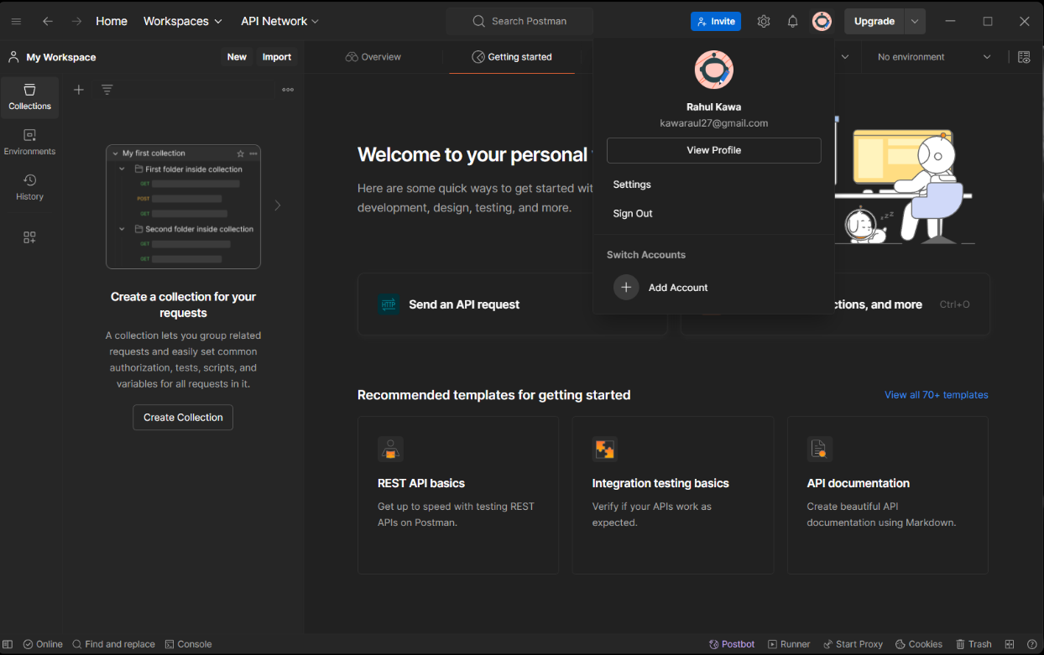

2. First Request
Steps
- Open Postman and create a new request.
- Set request type to GET & enter API endpoint https://pokeapi.co/api/v2/pokemon/ditto.
- Execute the request and examine the response.

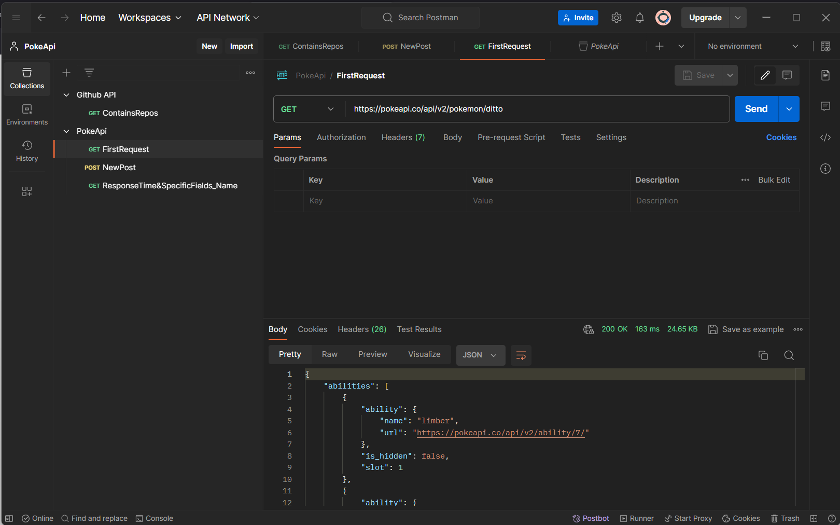
Observation: Gives every detail of the pokemon “ditto” & Status code: 200 OK

3. Organizing Requests into Collections
Steps
- Create a new collection in Postman, "PokeApi", to organize related requests.
- Add the request created in the previous task (FirstRequest) to the collection.
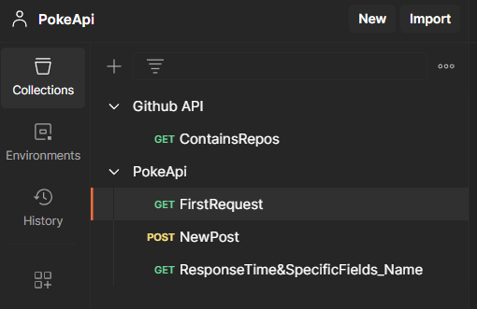

4. Test Scripts – POST request
For the Post request, I have used the website: Reqres.in
- Is a straightforward and freely accessible API designed for testing and prototyping.
- It allows users to send POST requests to generate new resources.
- For detailed information on how to use this API, refer to the documentation available at https://reqres.in/.
Created a new user: https://reqres.in/api/users
Body Tab - To add new user.
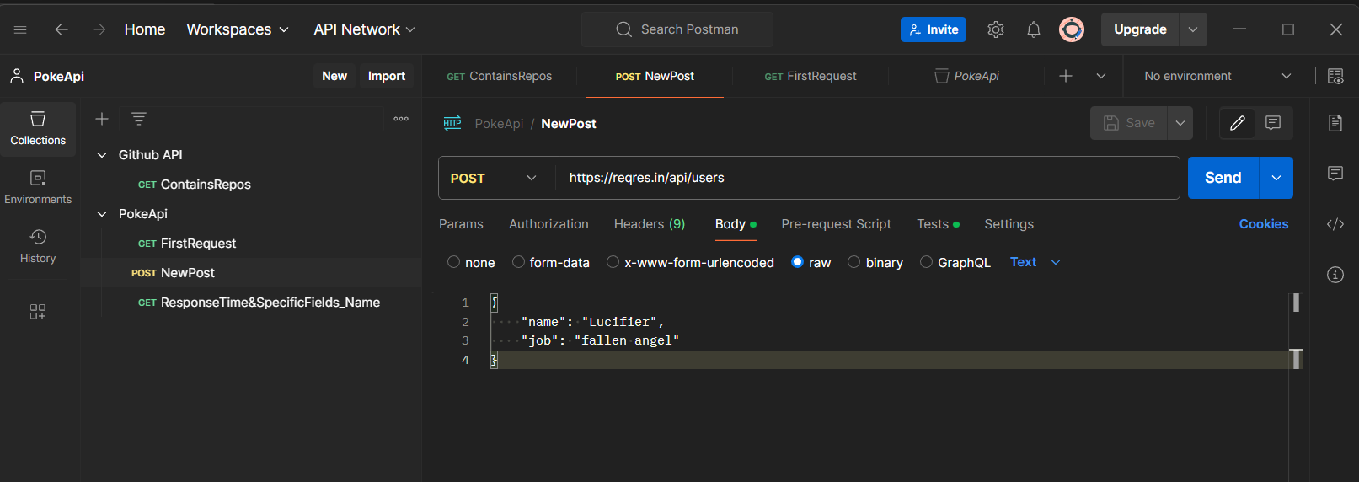
Tests Tab
- Wrote a test script to check the response status code ‘201’ for the successful creation of the user.
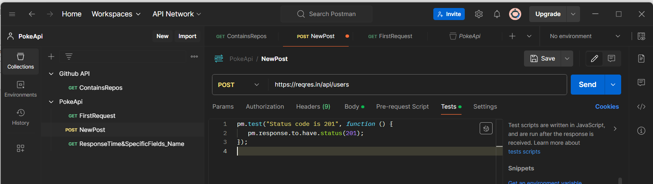
Response & Test Results
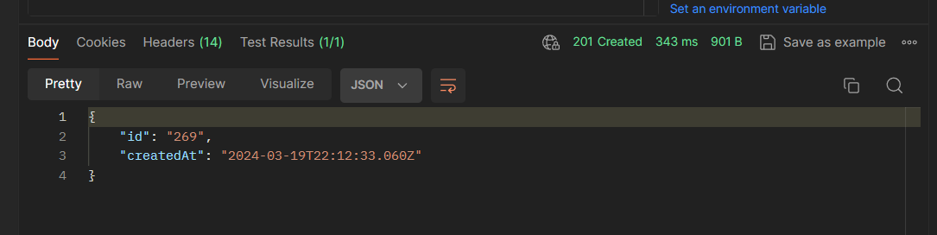
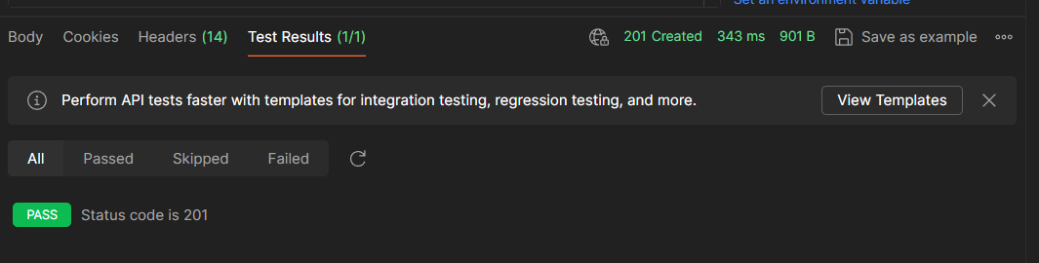
Observation: Create a new user, “lucifier”, and in response it provided with ID and Creation date and time & Status code: 201 Created

5. Adv. Testing Scenarios
Testing Response time and Specific Fields (ability name = “limber” for Ditto)
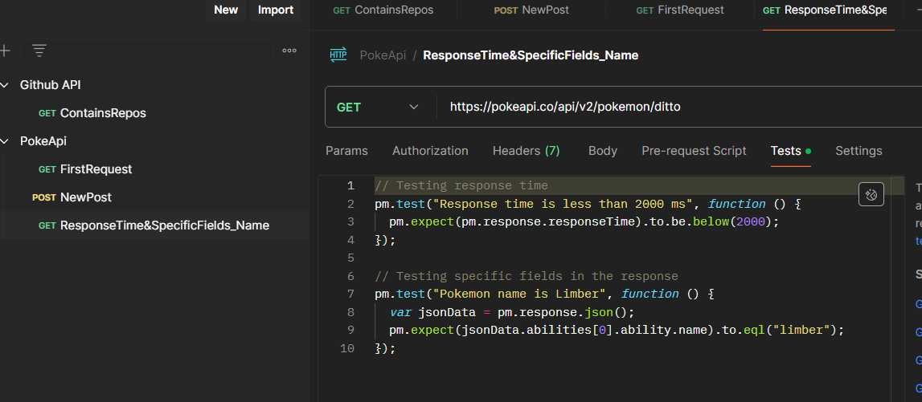
Passed
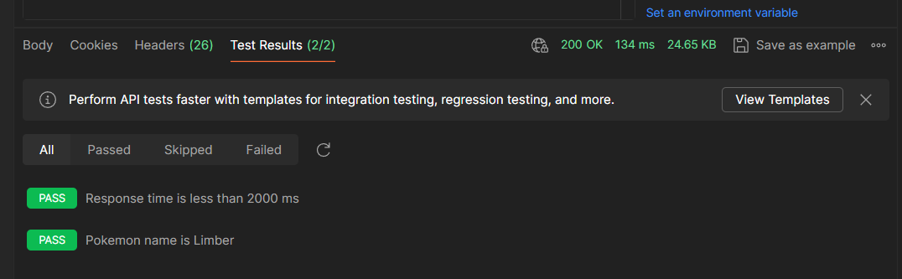
Failed
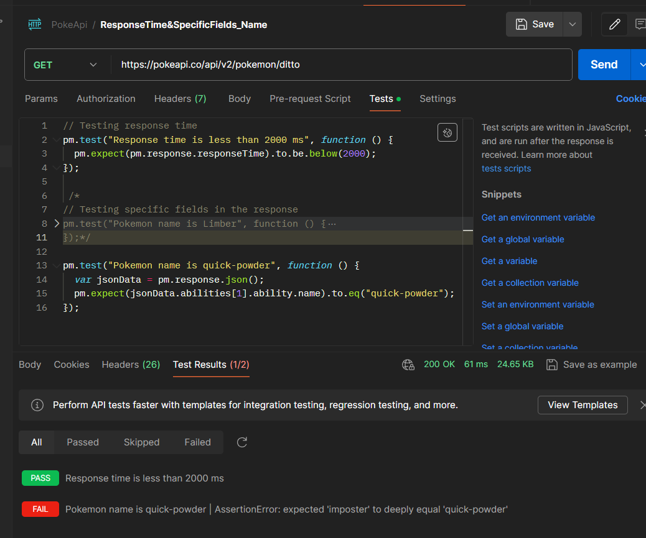
Observation:
- For both cases, Response time has passed.
- In Passed Case: Contains ability name = “limber” & Status code: 200 OK
- In Failed Case: Checking second ability name = “quick-powder” is false, but it has “imposter” as ability name.

6. Case Study: GitHub API
Accessing GitHub Profile in Postman using Personal Access Token
Generate Personal Access Token on GitHub:
- Navigate to your GitHub account and go to Settings.
- Under Settings, find "Developer settings" and select "Personal access tokens".
- Click on "Generate new token" or "Create a token".
- Specify the required permissions for the token, such as accessing repositories, user data, etc.
- Once configured, click "Generate token" and copy the generated token.
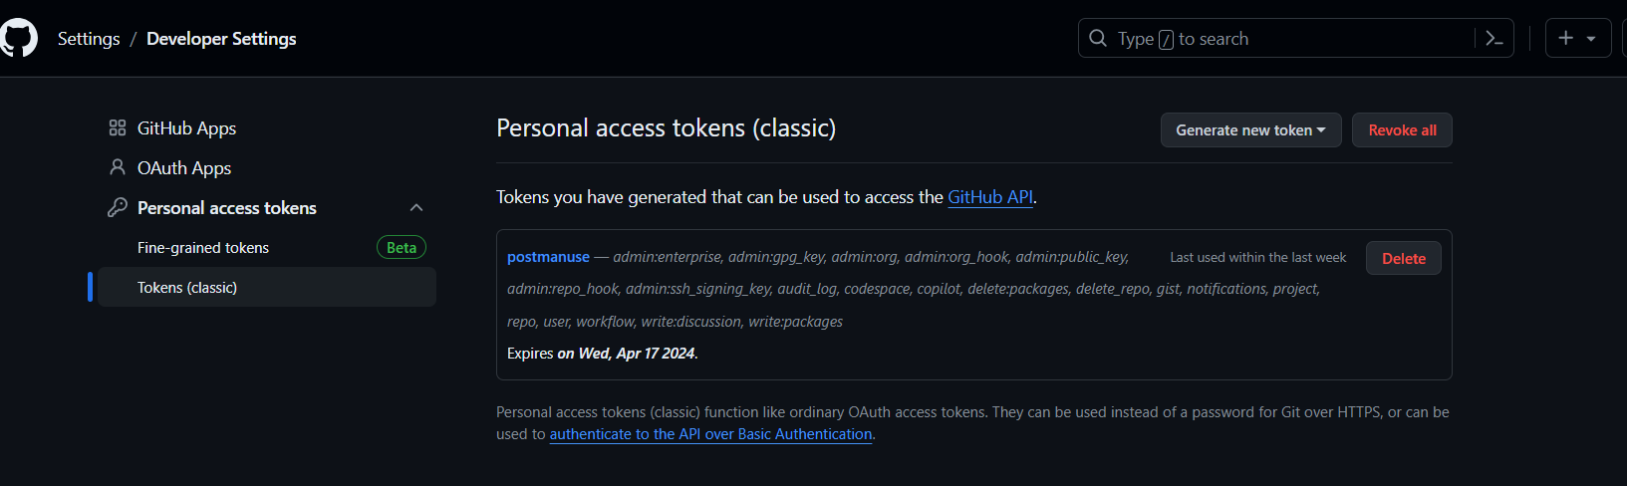
Configure Postman:
- Open Postman or download it if you haven't already.
- In Postman, create a new request or open an existing one to access GitHub APIs.
Authorization Configuration:
- Go to the "Authorization" tab in Postman.
Select Authorization Type:
- Choose "Bearer Token" from the dropdown menu.
Paste Personal Access Token:
- In the input field provided, paste the Personal Access Token you copied from GitHub.
Access GitHub API:
- Now, you can use Postman to send requests to GitHub APIs. Ensure that the endpoints you are accessing are compatible with the permissions granted to your Personal Access Token.
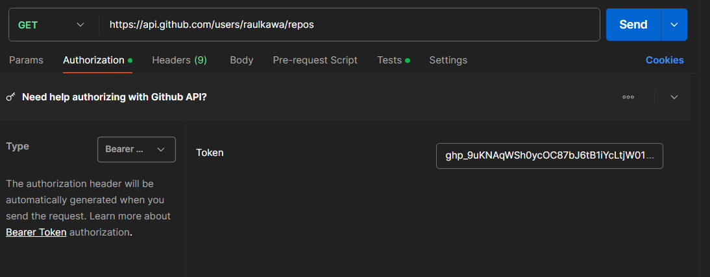

Test Scenarios
1. Get User’s Public Repositories
Endpoint: https://api.github.com/users/raulkawa/repos
Description: Retrieves a user's public repositories.
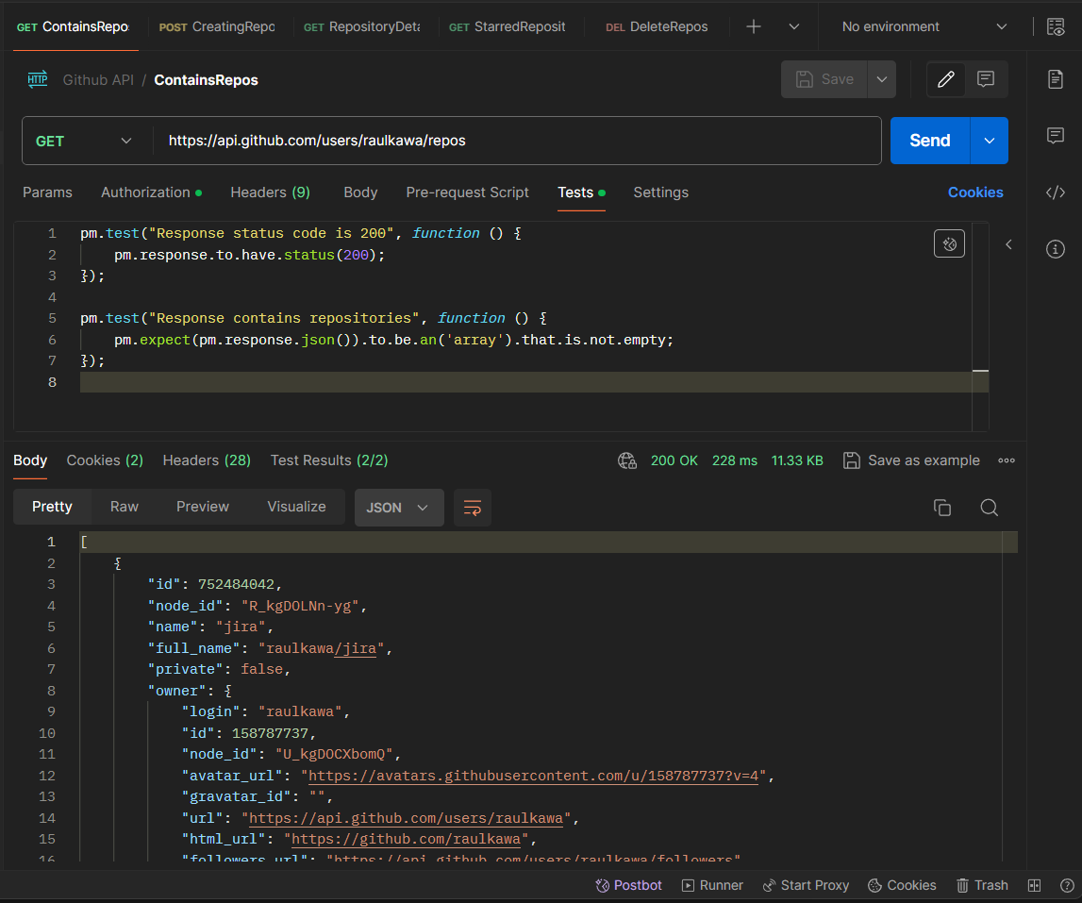
Observation: Gets repositories which are public & Status code: 200 OK

2. Creating Repository
Endpoint: https://api.github.com/user/repos
Description: Creates a new repository (new-repo) for the user.
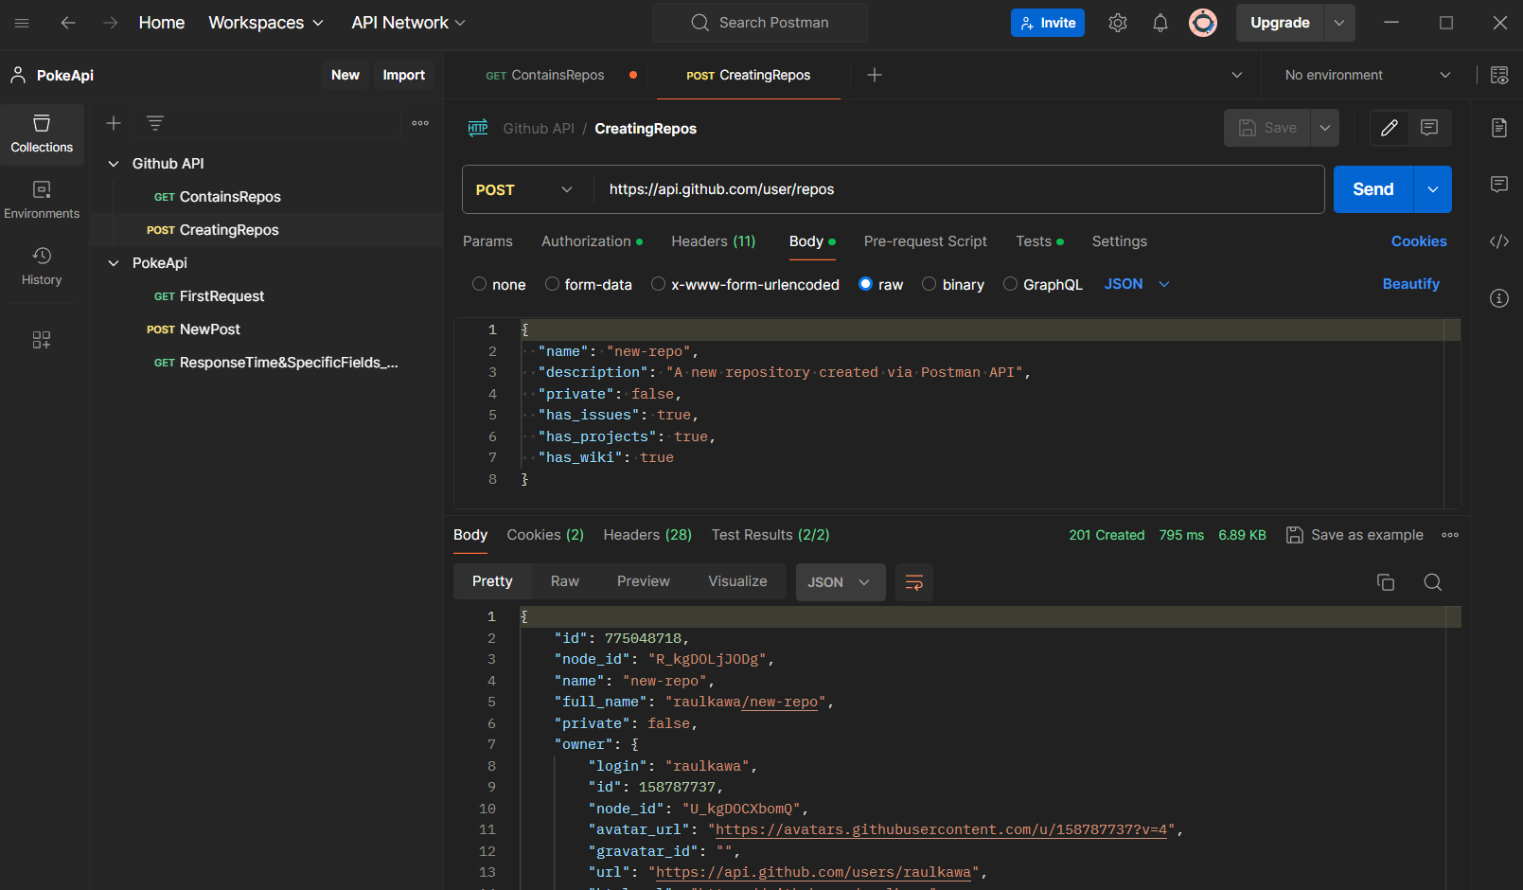
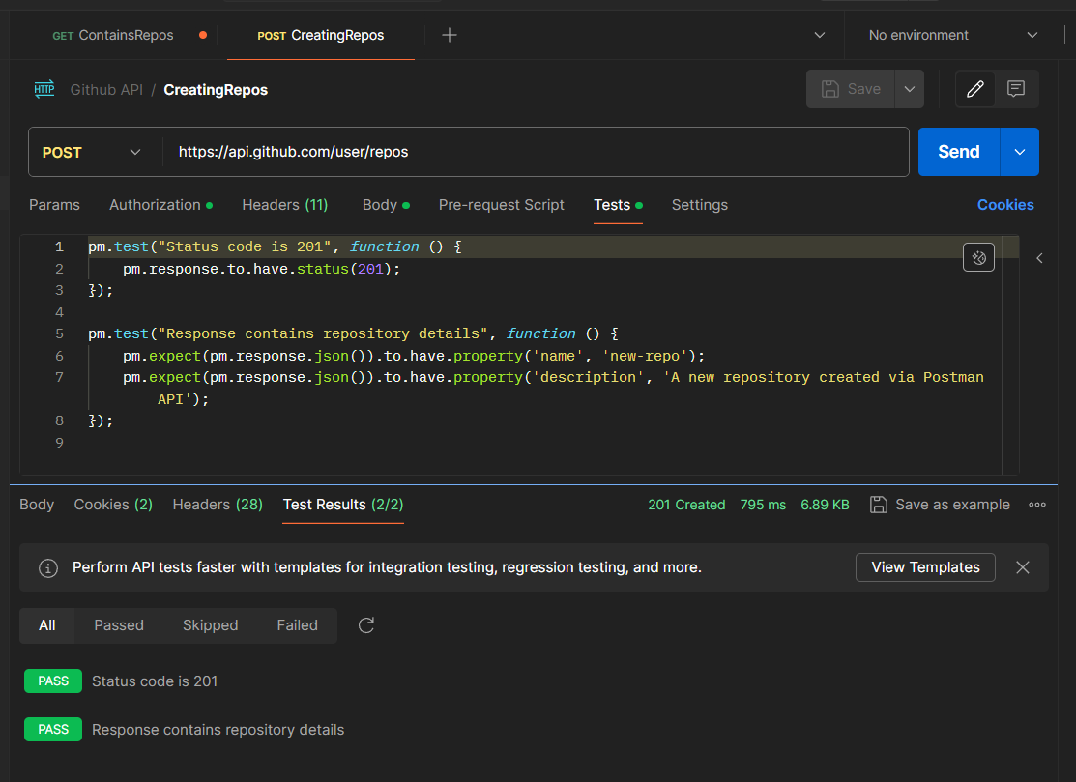

GitHub: Repository new-repo is created.
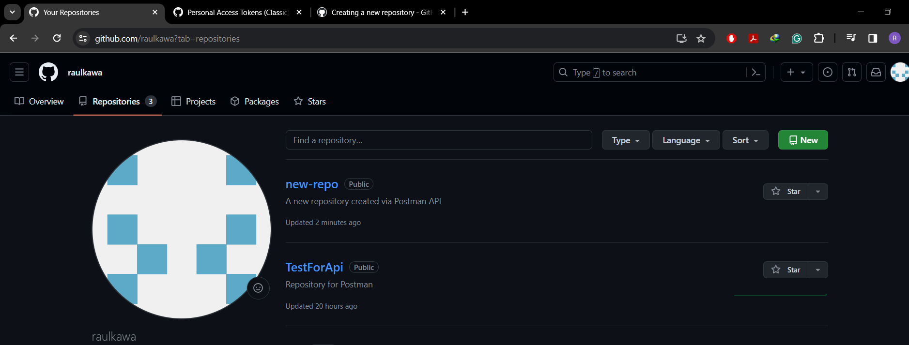
Observation: Created new repository in GitHub & Status code: 201 Created

3. Get Repository Details
Endpoint: https://api.github.com/repos/raulkawa/new-repo
Description: Retrieves details of a specific repository (new-repo).
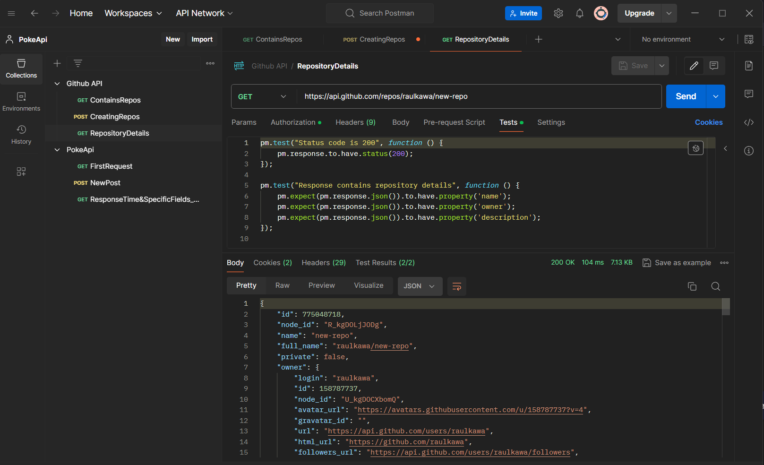
Observation: Gets details of repository (new-repo) & Status code: 200 OK
4. User’s Starred Repositories
Endpoint: https://api.github.com/users/raulkawa/starred
Description: Retrieves the list of repositories starred by a GitHub user.
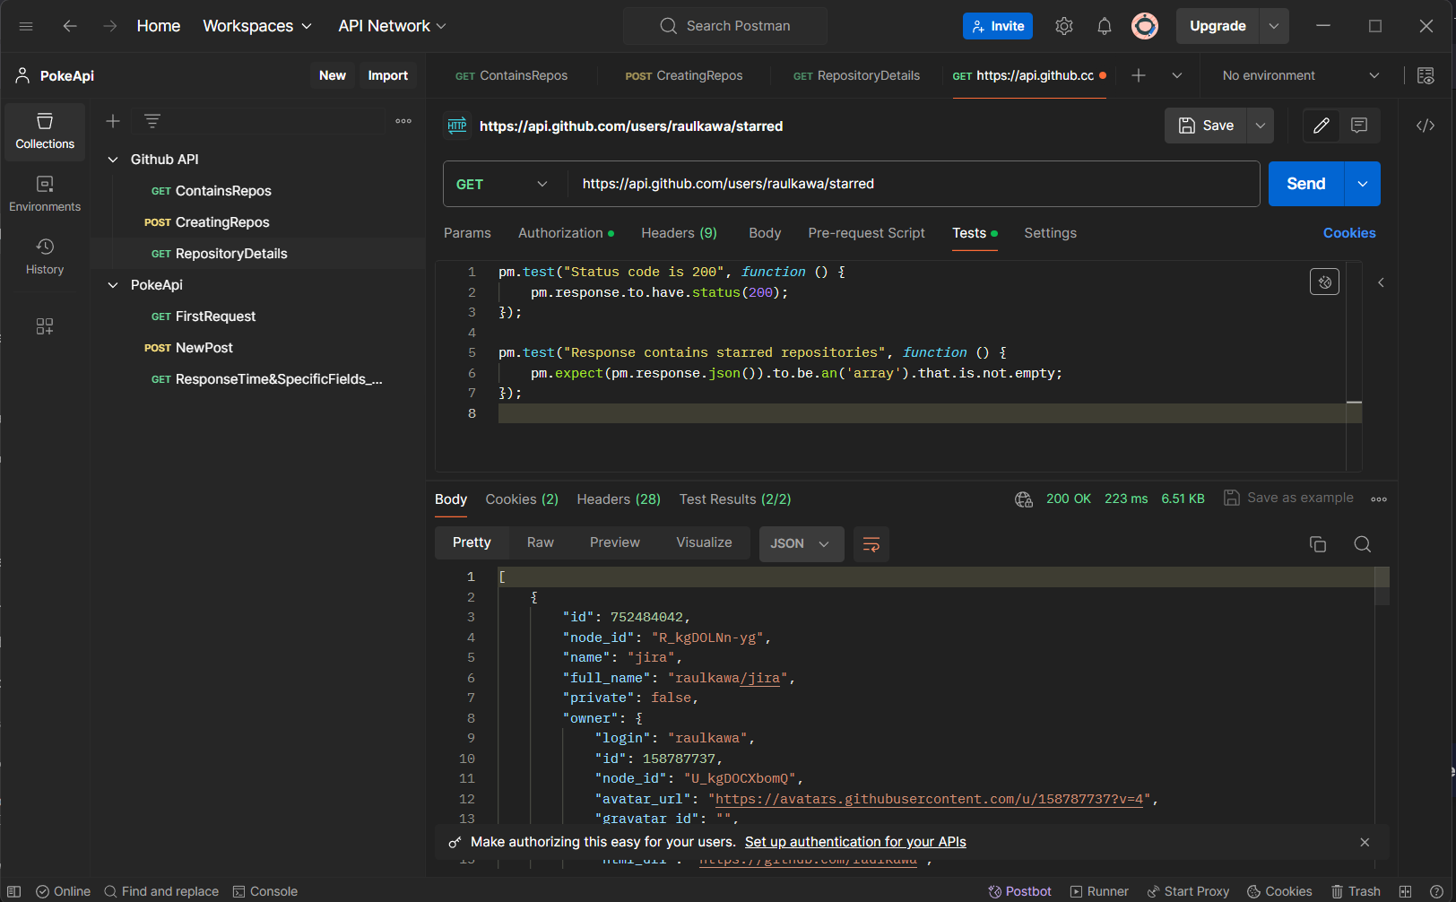
GitHub
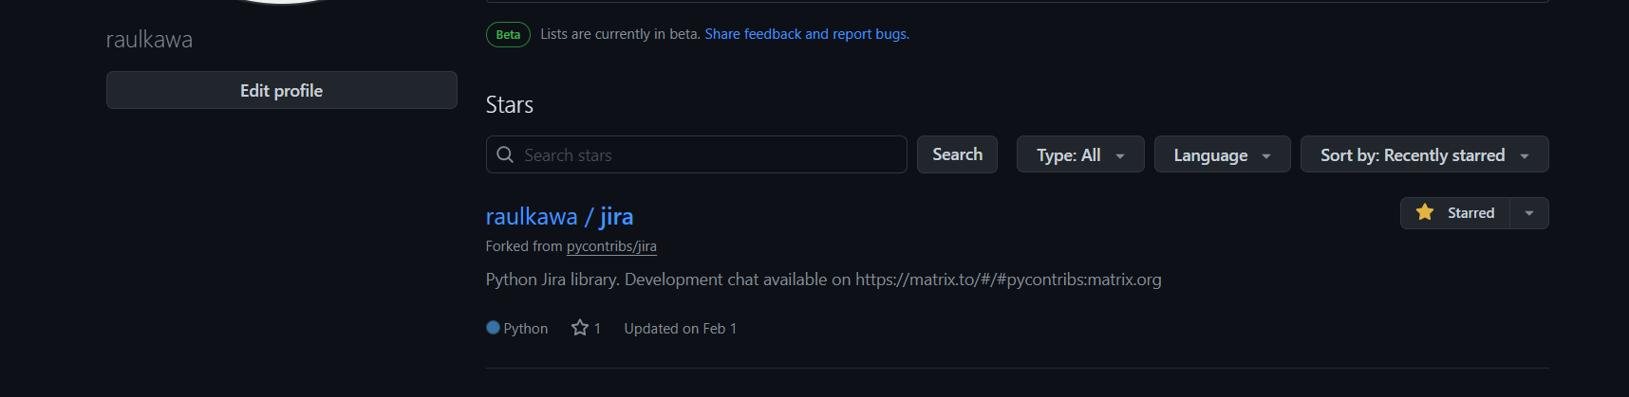
Observation: Gets list of Starred repositories (jira) from GitHub & Status code: 200 OK

5. Delete Repository in GitHub
Endpoint: https://api.github.com/repos/raulkawa/TestForApi
Description: Deleting a repository (TestForApi).
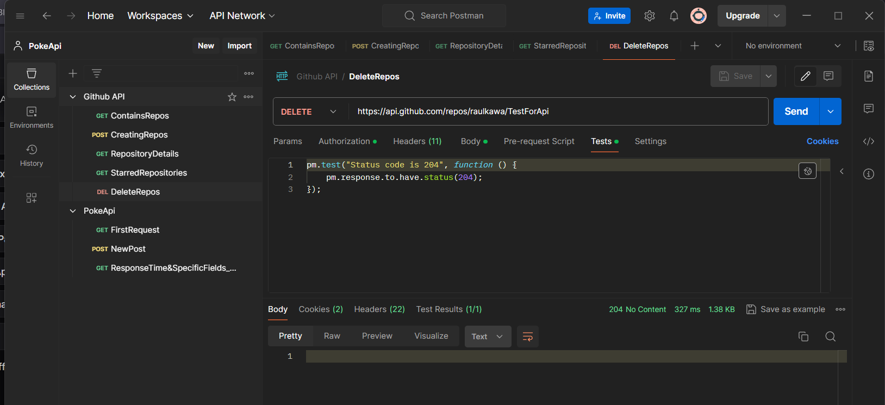
GitHub
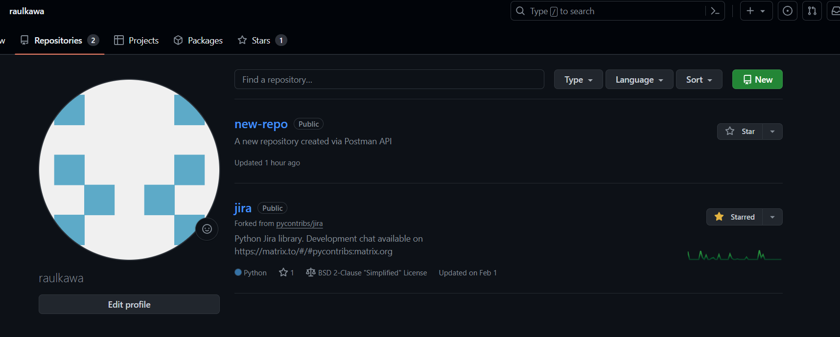
Observation: Deletes repository (TestForApi) from GitHub & Status code: 204 No Content

References
- What is Postman? Postman API Platform. (n.d.). Postman API Platform. https://www.postman.com/product/what-is-postman/
- GitHub.com help documentation. (n.d.). GitHub Docs. https://docs.github.com/en
- GitHub REST API documentation - GitHub Docs. (2022, November 28). GitHub Docs. https://docs.github.com/en/rest?apiVersion=2022-11-28

